**Deliverable 1**

1. **Group member names and responsibilities**

/*

**NOTE**: We have decided to follow a democratic approach where all of us take the lead (and act as Systems Analyst) depending upon our strongest qualities

*/

**Chris Zhao**

* Brainstormer / creative thinker
* Web organizer
* Note taker

**Devroop Banerjee**

* Information gatherer
* Brainstormer
* Communication manager

**Hongyu Dai**

* Boosts team morale
* Keeps team in check
* Brainstormer

**Tariq Chatur**

* Handles most of the written documentation
* Public Speaker
* Graphic design/powerpoints

**Xuyao Qin**

* Supports team members
* Improves team spirit
* All-rounder

**Wanjin Yoo**

* Supports team members
* Dedicated team member (all-rounder)
* Brainstormer

**2. Client Name & Organisation Type**

**Client name**: The UVSS Food Bank and Free Store

**Information**: A Non-profit Organisation located in the basement of the SUB, aiming to provide all UVic students with regular and reliable access to food staples and free household items.

**3. Brief Description of the System under study**

* **Tracking of inventory**, currently a paper based system that is in the layout of an excel document. It takes up space and can be easily damaged, lost, or destroyed
* **Used by the users of the food bank**, to show what they have taken; overviewed by the Food Bank and Free Store Coordinator. The system interacts with the customers and staff of the food bank
* **The current information gathered is not trustworthy** as mistakes are often made in tracking the products
* Items are often donated which are put in the storage room with other items, **none of which are tracked**

**4. Problem Definition**

* The current UVSS food bank and free store **lacks an online and paperless inventory management system**
* The current management system is **inefficient**
* The food bank has a tight budget and any unaccounted losses/theft need to be discovered

**5. Objective of study and possible benefits to be gained**

* Digitise inventory
* Update the inventory online so that students know what is available
* Keep tabs on whether the students are taking the amount of food allotted to them
* Properly structure records of incoming food delivery
* Keep tabs on individual food items to understand if the right amount is being delivered

**6. Use case diagram and Specification**

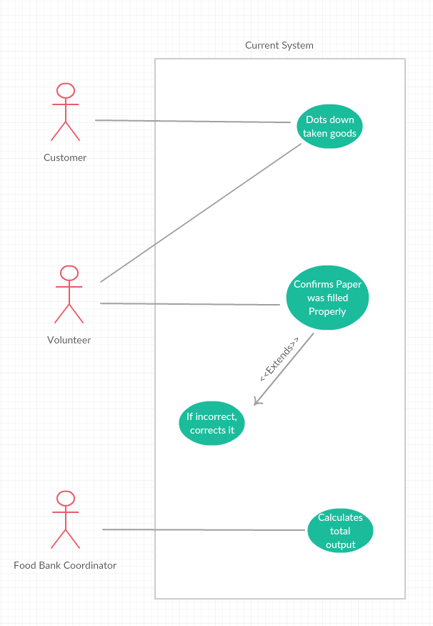

**7. Use case specification**

Case 1: Dots down taken goods

Actors : Customer, Volunteer

Preconditions : There is food at food bank and and the customer is a student at UVIC.

Steps:

1 . Count how items the customer takes.

2. Write down the number of items.

Success condition : The number of items taken by the customer is recorded to the system

Alternative path : None.

Case 2: Confirm record is filled properly

Actors: Volunteers

Preconditions: Customer has finished taking goods and filling the record.

Steps:

1. Check the content that customer filled in the record and compare with the items customer has taken.

2. If record is wrong, erase the wrong record and correct it.

Success condition: The record has been confirmed and updated rightly .

Alternative path: None

Case 3: Compute the total output

Actors: The foodbank coordinator

Preconditions: The previous in-and-out records are stored and handed to the coordinator properly.  
 Steps:

1. Compute the monthly inventory flow based on the existing records.

2. Match the flow with the current inventory stock.

Success condition: The inventory stock matches the total output flow.

Alternative path: None

**8. Opportunities – what skills / abilities can the team bring to solving the problem**

As 3rd and 4th broke computer science students, we have the reason, passion, and knowledge to make the food bank’s system better. Besides, grades and GPA are huge motivators when it comes to bringing the team together. Finally, one of our members is a volunteer at the food bank and he has previous knowledge of the system.

**9. Brief project plan and gantt chart showing what has been done and what will be done during the remainder of the term**

So far, we have -

* Updated the website every week
* Did a sufficient amount of background research by interviewing the coordinator and coordinator assistant of the food bank
* Brief discussion about the solution
* Made the RFP/Pitch
* Made the survey for the food bank staff and users

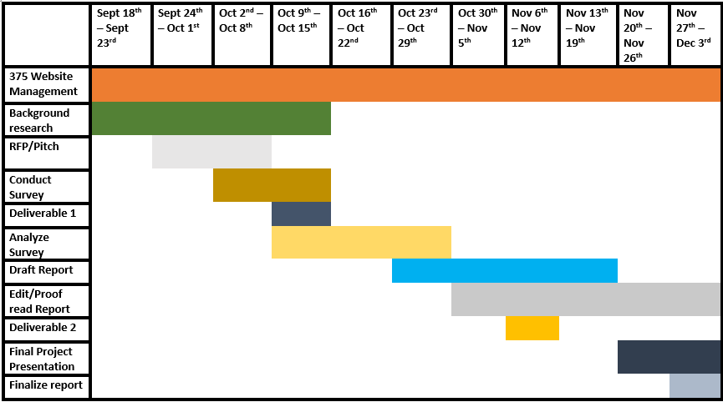

What we intend to do -

* Use the survey to collect more information
* Observe other food bank staff/users
* Analyze the data gathered from survey/ethnography
* Alternative solutions as our current idea has been rejected
* Discuss our options with the food bank and the programmer
* Start preparing a rough draft, continue working on it till the end of the semester
* Deliverables, final presentation and final report